# **Lab 2**

# **Hands-On Lab: Watson Assistant**

In this lab you will learn how to create a Watson-powered chatbot solution that concentrates on the context of each question and leverages machine learning approaches to train the virtual agent on a specific domain. Upon completion of this lab, students will be able to pair Watson Assistant with Watson Discovery in order to create a chatbot that can answer questions about severe weather events in the United States.

The core use case presented is the development of a virtual agent capability that can be trained to answer natural language questions about severe weather events in the United States from 2013-2018. The virtual assistant will retrieve information from the corpus of weather data previously loaded in the Watson Discovery lab in order to answer questions that are typed directly into the Watson Assistant chat-box.

**Prerequisites:**

* IBM Cloud Account (Use <https://console.bluemix.net> to sign up for a new account before starting the labs)
* Completed Lab 1 – Watson Discovery
* Access to lab and PoT assets at <https://github.com/cerebralace/WatsonPoT>

**Step 1: Create and Launch Watson Assistant Instance**

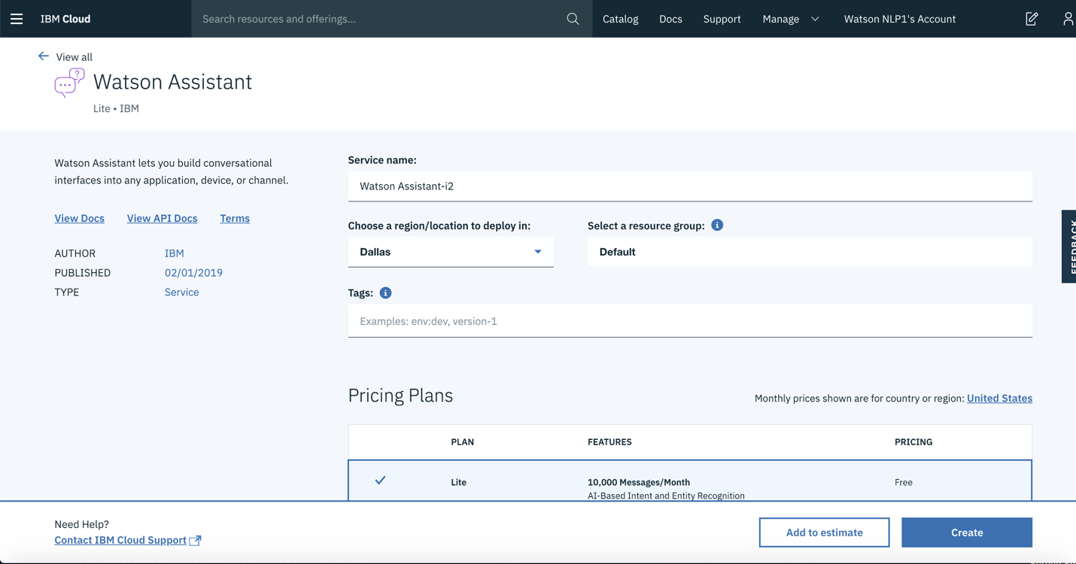

1. Create an instance of the Watson Assistant service:
   * Log in to your IBM Cloud account.
   * Go to the [Watson Assistant](https://cloud.ibm.com/catalog/services/watson-assistant) page in the IBM Cloud Catalog.
   * Give your service a unique name (or keep the generated name), select the **Dallas** region and **Default** resource group.
   * Make sure the **Lite** edition is selected under **Pricing Plans**
   * Click **Create**.
2. Select your instance and launch Watson Assistant:
   * On the [Resource list](https://cloud.ibm.com/resources) page, double click your Watson Assistant service under **Services**

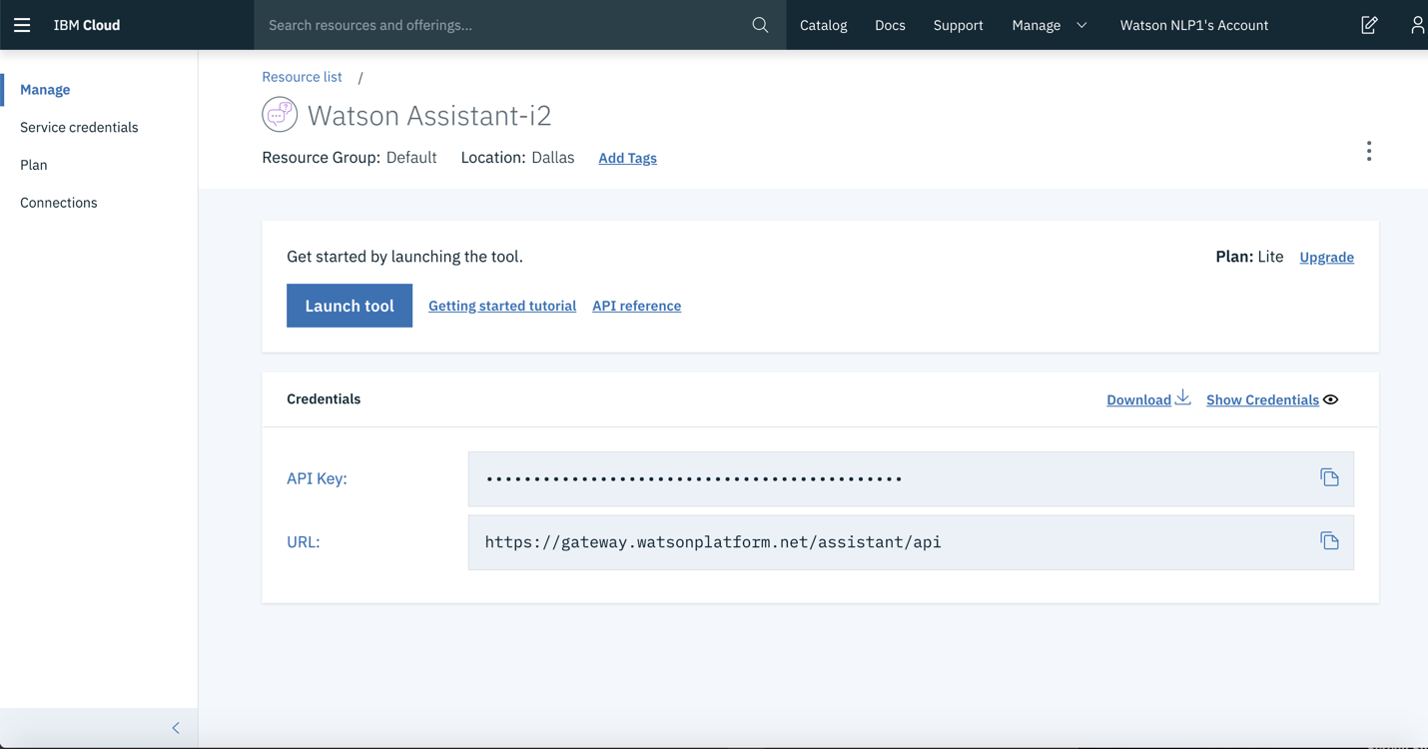

* + Click **Launch tool**

**Step 2: Initialize a Dialog Flow**

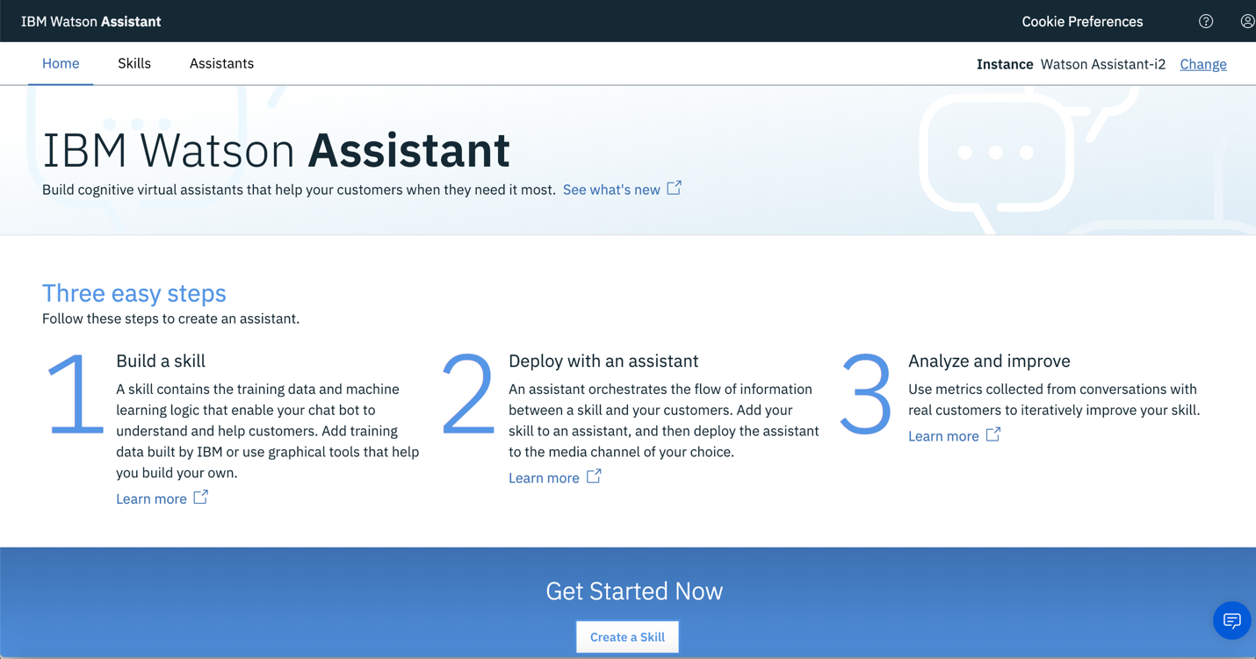

1. Once you are on the Watson Assistant home page, the first thing you will need to create is a skill (a set of intents and entities) as well as a dialog flow that will be embedded into your chatbot. Click **Create a Skill**

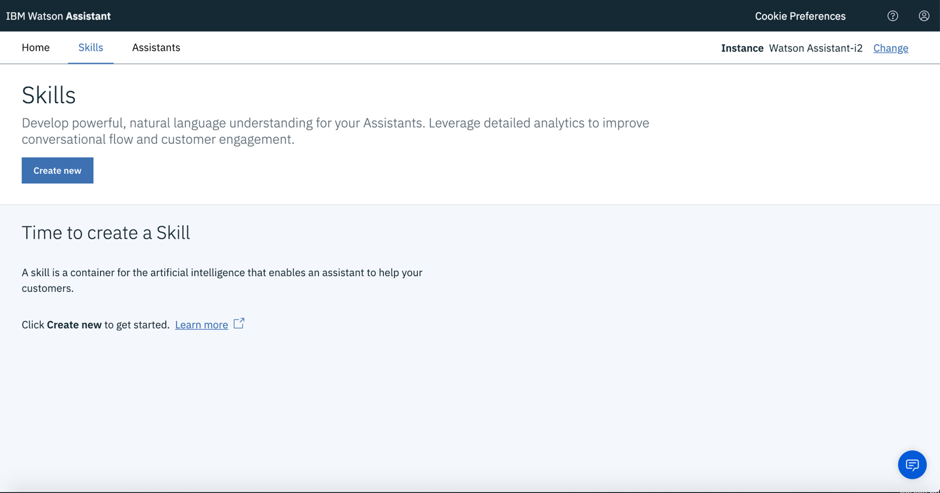

1. Under Skills, click **Create new**

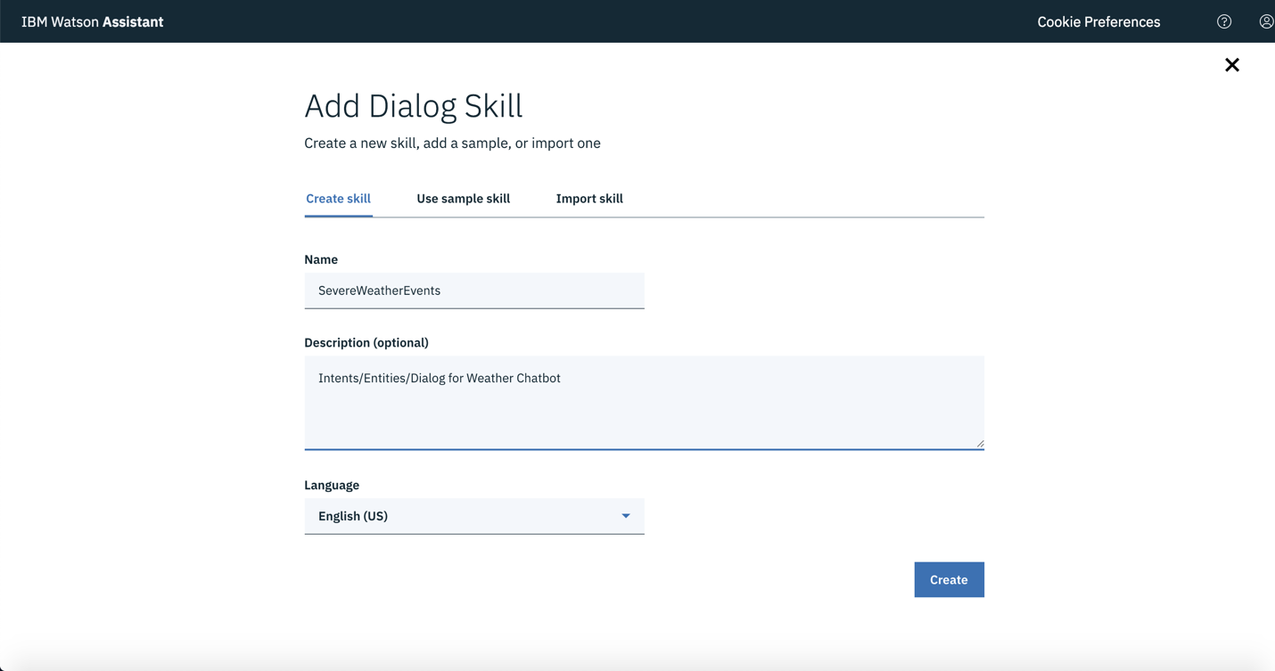

1. To create a new dialog skill, give it a new **Name** (e.g. SevereWeatherEvents), an optional **Description** and keep the Language as **English(US)**. Click **Create.**

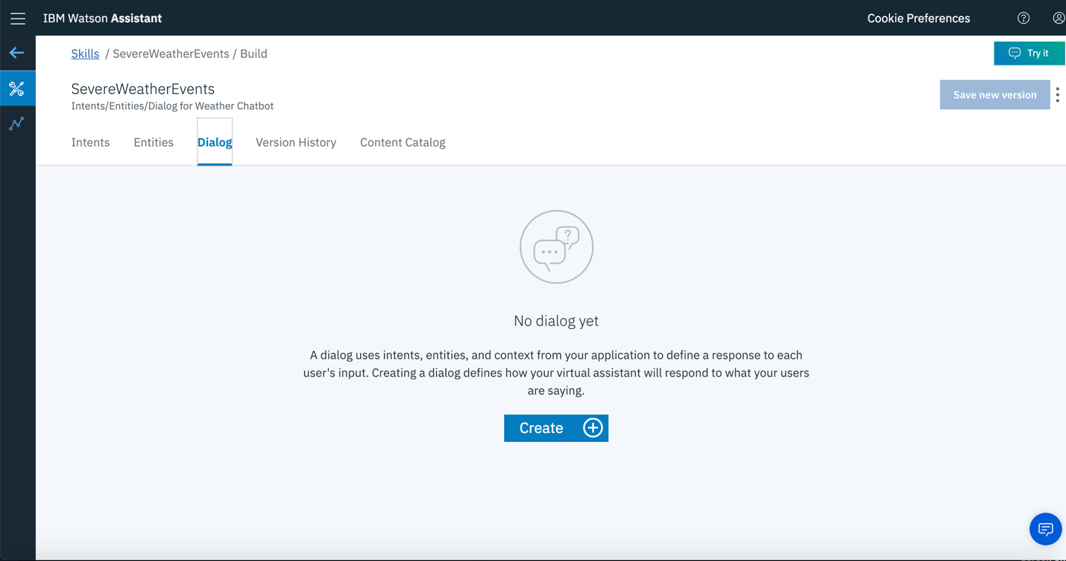

1. To start creating a dialog, click the **Dialog** tab and click **Create**

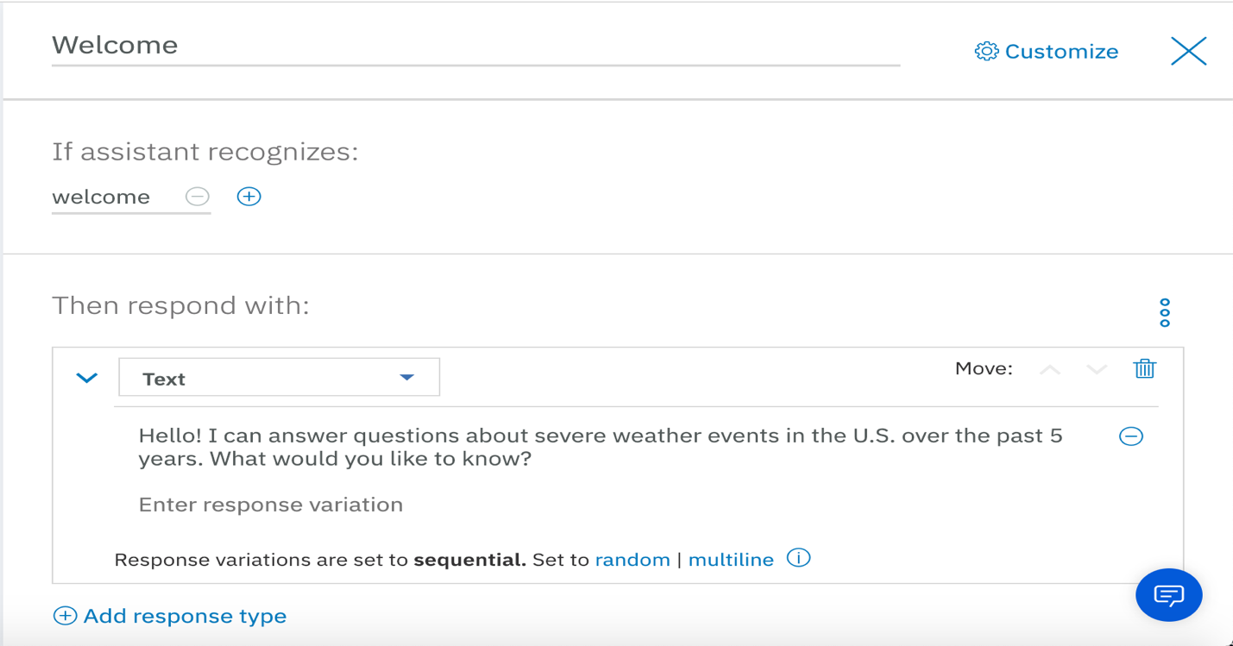

1. The user will be first greeted by a welcome message. Click on the **Welcome** node and on the right side of the screen, type *welcome* under **If assistant recognizes**, and under **Then respond with** write *Hello! I can answer questions about severe weather events in the U.S. over the past 5 years. What would you like to know?* To save this node, click the X button next to the Customize option.
2. If you completed the previous lab on Watson Discovery, you should know that we will be training our Watson Assistant instance on the query results saved in our QueryResults.txt file. Thus, we will create nodes for each of the 5 questions. But first, we will need to create a list of intents and entities so that our virtual assistant can quickly understand our users’ questions.

**Step 3: Create Intents and Entities**

1. Click on the **Intents** tab and click **Add intent**

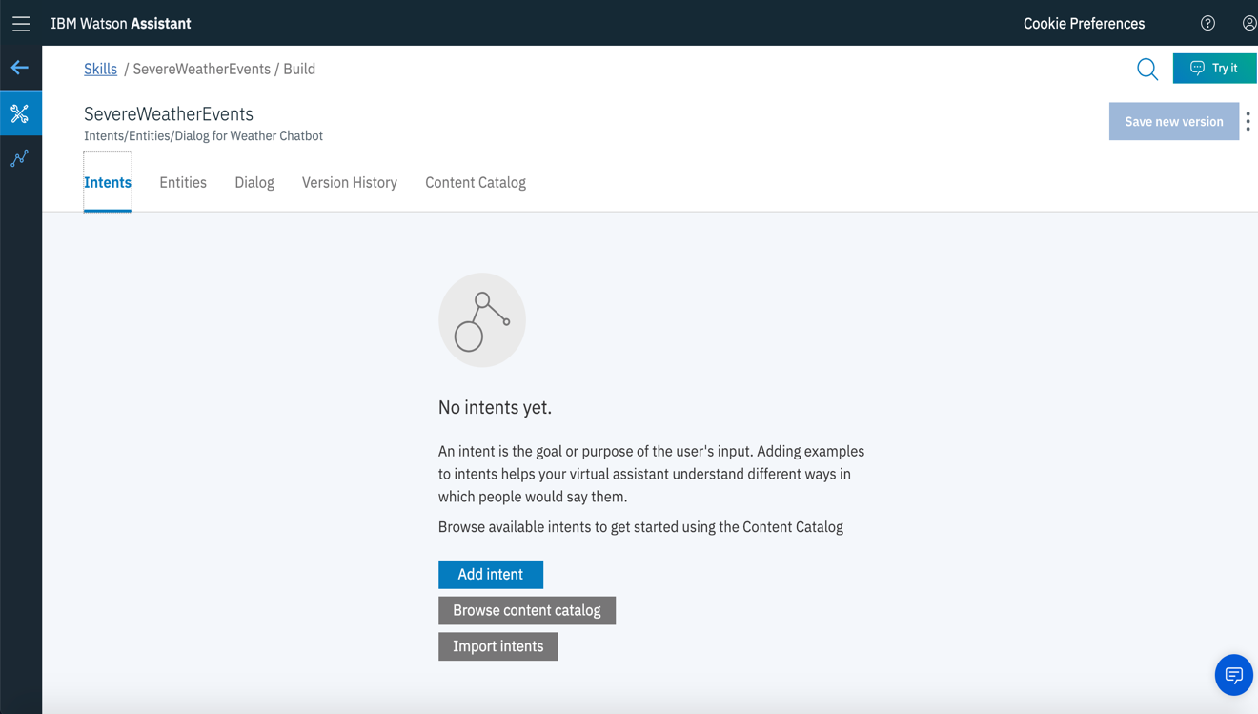

1. Let’s create the first intent pertaining to the first question.

* Give the intent the name, #mostcommonevents, a description of *most common severe weather events* and click **Create intent**
* Under **Add user examples**, add the following examples of the various ways a user might ask the first question:
* Most common events
* Most common severe weather events
* Most common severe weather events in 2018
* Most common weather events
* Most common weather events in 2018
* The most common severe weather events in 2018
* The top 5 most common events in 2018
* Top 5 most common severe weather events in 2018
* What were the most common severe weather events in 2018?
* What were the top 5 most common severe weather events in 2018

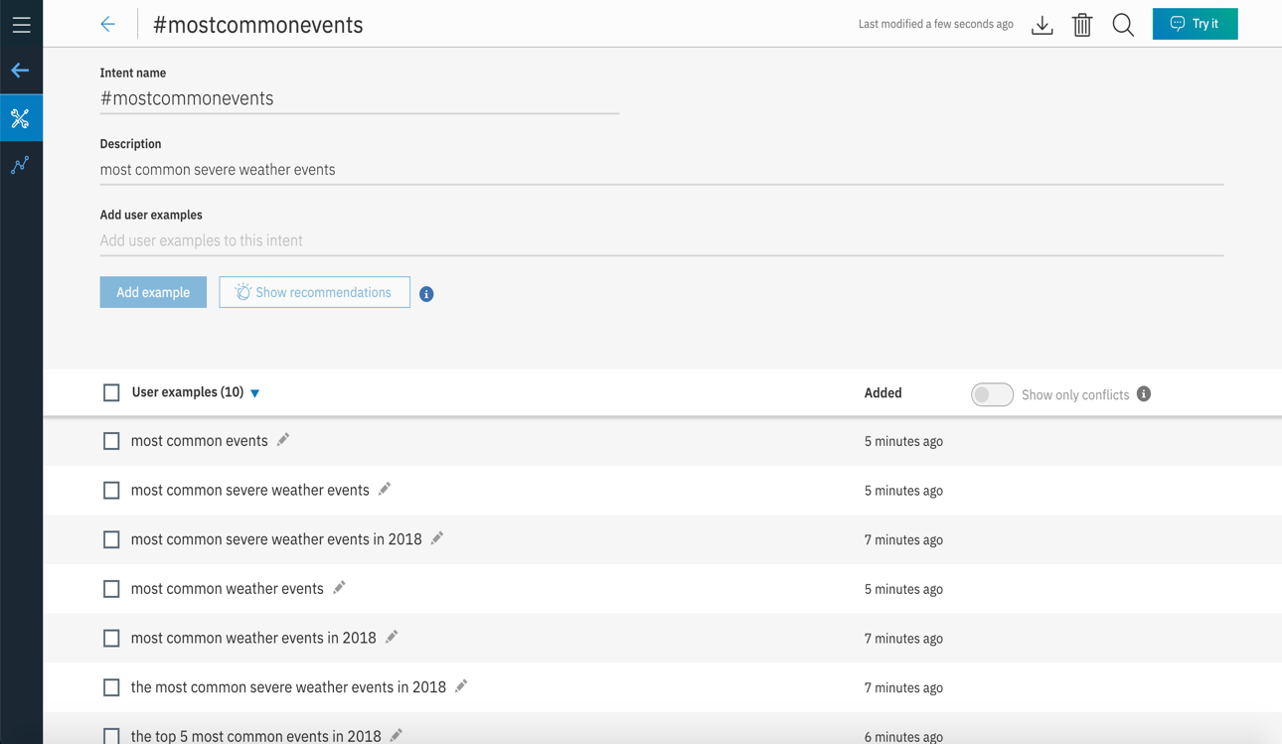

1. Let’s create a few entities pertaining to the first question. Entities will allow Watson to understand alternate meanings or versions of words that a user might use in their questions.

* Click the back arrow to return to the Skills screen
* Click the **Entities** tab and click **Add entity**

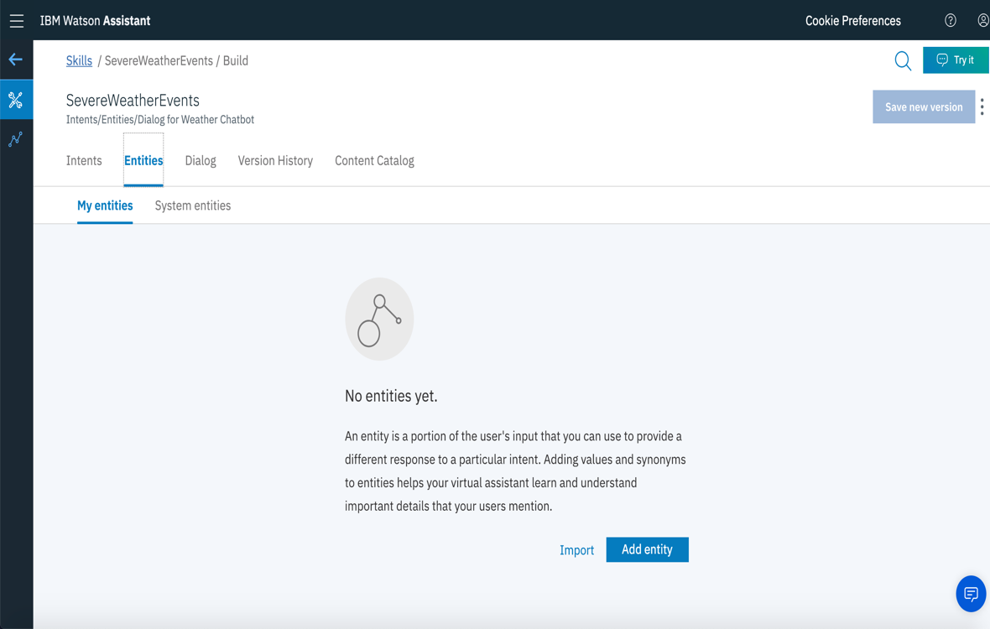

* Give the entity the name @**common** and click **Create entity**
* Enter **Value name** of **common** and under **Synonyms** add the following synonyms by typing and click the plus sign after typing each one: **common**, **most common**, **top 5**, **top five**, **the top**, **the main.** Click **Add value** to save the entity.

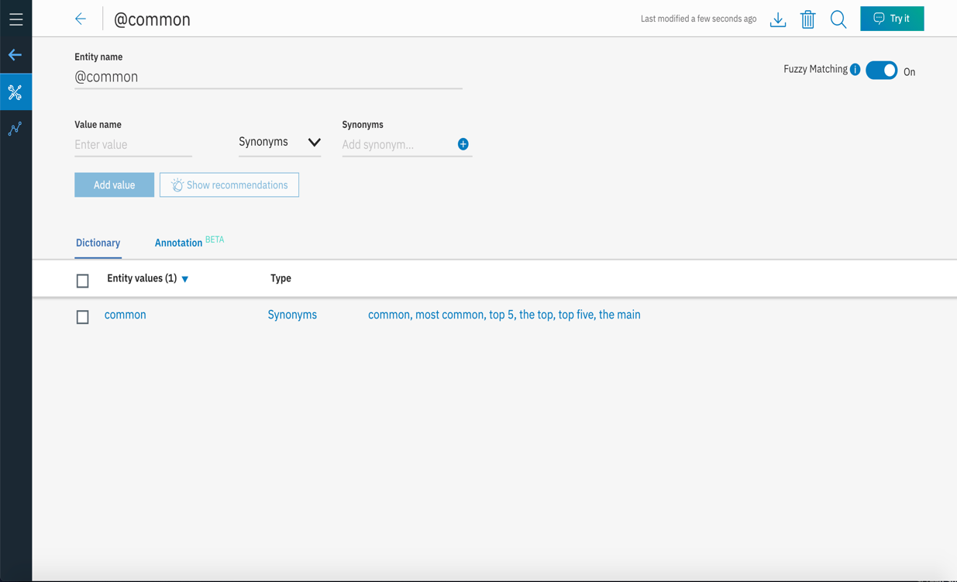

* Click on the back arrow and return to the Skills page to add another entity
* Click **Add entity**
* The entity name will be **@events** and click **Create entity**
* Enter the **Value name** as **events** and the following **Synonyms: event**, **weather event**, **weather events**, **severe weather event**, **severe weather events**
* Click **Add value** to save this entity and then click the back arrow to return to the Skills screen

1. Let’s create the second intent pertaining to the second question.

* Click on the **Intents** tab and click **Add intent**
* Give the intent the name, #weatherdeaths, a description of *deaths associated with most common weather events* and click **Create intent**
* Under **Add user examples**, add the following examples of the various ways a user might ask the first question:
* Deaths from most common events
* Deaths from most common severe weather events
* Deaths from most common severe weather events in 2018
* Deaths from most common weather events
* Deaths from most common weather events in 2018
* The death count from the most common severe weather events in 2018
* The number of deaths associated with the top 5 most common events in 2018
* Deaths from the top 5 most common severe weather events in 2018
* What were the number of deaths from each of the most common severe weather events in 2018?
* What were the death tolls from the top 5 most severe weather events in 2018

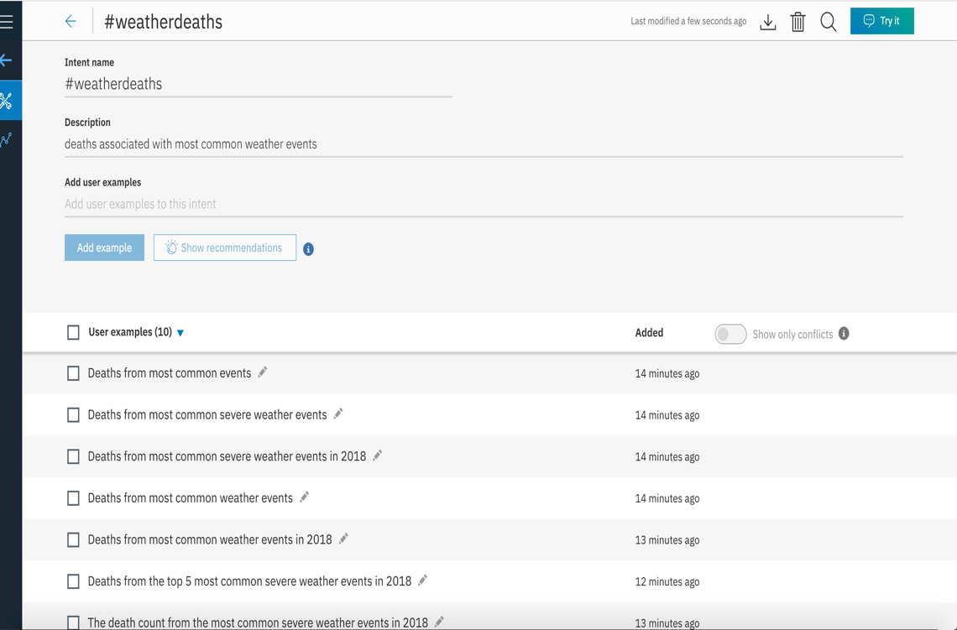

1. Let’s create an entity pertaining to the second question.

* Click the back arrow to return to the Skills screen
* Click the **Entities** tab and click **Add entity**
* Give the entity name of **@deaths** and click **Create entity**
* Enter **deaths** as the **Value name** and the following synonyms: **death**, **number of deaths**, **death count**, **death toll**, **death tolls**, **total number of deaths**, **total deaths**, **mortality**, **mortality rate**
* Click **Add value** and click the back arrow to return to the Skills screen

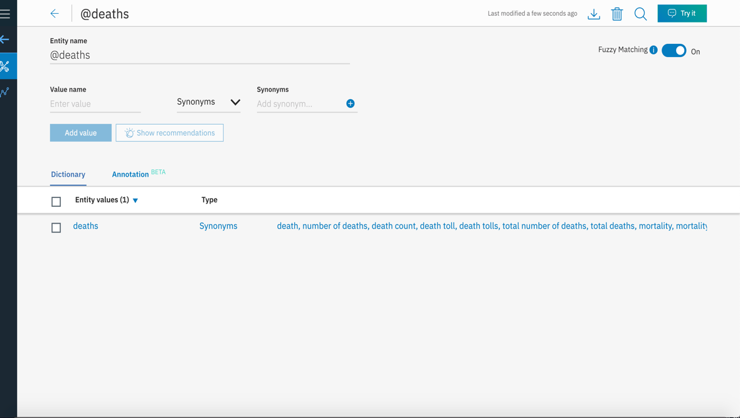

1. Click on the **Intents** tab to start creating the intent for the third question. Click **Add Intent** to begin.

* Give the intent the name, #hailplaces, a description of *top 5 states affected by hail in 2018* and click **Create intent**
* Under **Add user examples**, add the following examples of the various ways a user might ask the first question:
* Top 5 states affected by hail
* Top states affected by hail
* Top 5 states affected by hail in 2018
* States most affected by hail in 2018
* Top 5 states most affected by hail
* Top states most affected by hail
* Top 5 states most affected by hail in 2018
* States affected by hail in 2018
* Places affected by hail in 2018
* Top 5 places affected by hail
* Once you’re done creating this intent, click the back arrow to return to the Skills page

1. Let’s create some entities for the third question.

* Click the **Entities** tab and click **Add Entity**
* Enter the entity name @**affected** and click **Create entity**
* Enter the value name of **affected** and the following synonyms: most affected, afflicted, most afflicted
* Click **Add value**
* Click the back arrow and create another entity by clicking **Add entity**
* Enter the entity name **@states** and click **Create entity**
* Enter the value name of **states** and the following synonyms: **state**, **places**, **place**, **locations**, **location**
* Click **Add value** and return to the Skills screen by clicking the back arrow

1. By now, you will have created 3 intents and 5 entities. We will now create an intent and a few entities for the fourth question.

* Click the **Intents** tab and click **Add intent**
* Name it *#worsttornados*, give it a description of *worst tornados* *in past 5 years* and click **Create intent**
* Under **Add user examples**, add the following examples of the various ways a user might ask the first question:
* What were the most severe tornados from 2013-2018
* The most severe tornados
* The worst tornados
* Determine the rating and locations of the most severe tornados from 2013-2018
* The rating and locations of the most severe tornados
* The score and locations of the most severe tornados
* Determine the rating and locations of the worst tornados from 2013-2018
* The score and locations of the worst tornados from 2013-2018
* The score and locations of the worst tornados
* Where did the most severe tornados occur in the past 5 years
* Where did the worst tornados take place in the past 5 years?
* Click the back arrow to return to the Skills screen and start creating some entities. Click the **Entities** tab and click **Add Entity**
* Enter the entity name **@rating** and click **Create entity**
* Enter **rating** as the **Value name** and add the following synonyms: **score**, **intensity**, **magnitude**, **EF scale**, **EF score**
* Click **Add value** and click the back arrow to return to the Skills page
* Click the **Entities** tab and click **Add entity**
* Enter the **Entity name** of **@severity** and click **Create entity**
* The **Value name** will be **severity** and add the following synonyms: most severe, worst, most devastating, most disastrous
* Click **Add value** and click the back arrow to return to the Skills page

1. Now it’s time to create an intent and a few entities for the fifth question.

* Click the **Intents** tab and click **Add intent**
* Name it *#winterstorms,* give it a description of *states most affected by winter storms* and click **Create intent**
* Under **Add user examples**, add the following examples of the various ways a user might ask the first question:
* What were the states most affected by winter storms from 2013-2018
* States most affected by winter storms
* States most affected by winter weather
* What were the states most affected by winter weather from 2013-2018
* States most affected by snowfall from 2013-2018
* States most affected by snowfall
* What were the states most affected by snowfall from 2013-2018
* What were the states most affected by snowfall over the past 5 years
* Places most affected by winter weather
* Places that received the most snowfall in the past 5 years
* States that received the most snowfall
* Click the back arrow to return to the Skills screen and start creating some entities. Click the **Entities** tab and click **Add Entity**
* Enter the entity name **@winterweather** and click **Create entity**
* Enter **winter weather** as the **Value name** and add the following synonyms: **winter storms**, **snowfall**, **snow**
* Click **Add value** and click the back arrow to return to the Skills page
* Now that you have created all of the intents and entities that we need for the Watson Assistant instance (check to see that you have 5 intents and 8 entities), we can start adding our question nodes to the Dialog flow.

**Step 4: Create Question Nodes**

1. After the Welcome message, let’s create a multiple-choice selection node that allows users to pick and choose their specific question.

* Click the **Dialog** tab to show the Dialog flow
* Since we want the multiple-choice selection node to flow directly from the Welcome message, click on the Welcome node (so that it turns blue) and then click **Add child node**
* Name this node **Question Selection** and underneath **Then respond with** select the drop-down to Option and click **Add option**
* Enter the first label as **Top 5 Events in 2018** and the value as **most common events**. Click **Add option**.
* Enter the second label as **Death Toll from Top 5 Events in 2018** and the value as **weather deaths**. Click **Add option**.
* Enter the third label as **States most affected by hail in 2018** and the value as **hail places**. Click **Add option**.
* Enter the fourth label as **Worst tornados from 2013-2018** and the value as **worst tornados**. Click **Add option**.
* Enter the fifth label as **States most affected by winter storms from 2013-2018** and the value as **winter storms**.

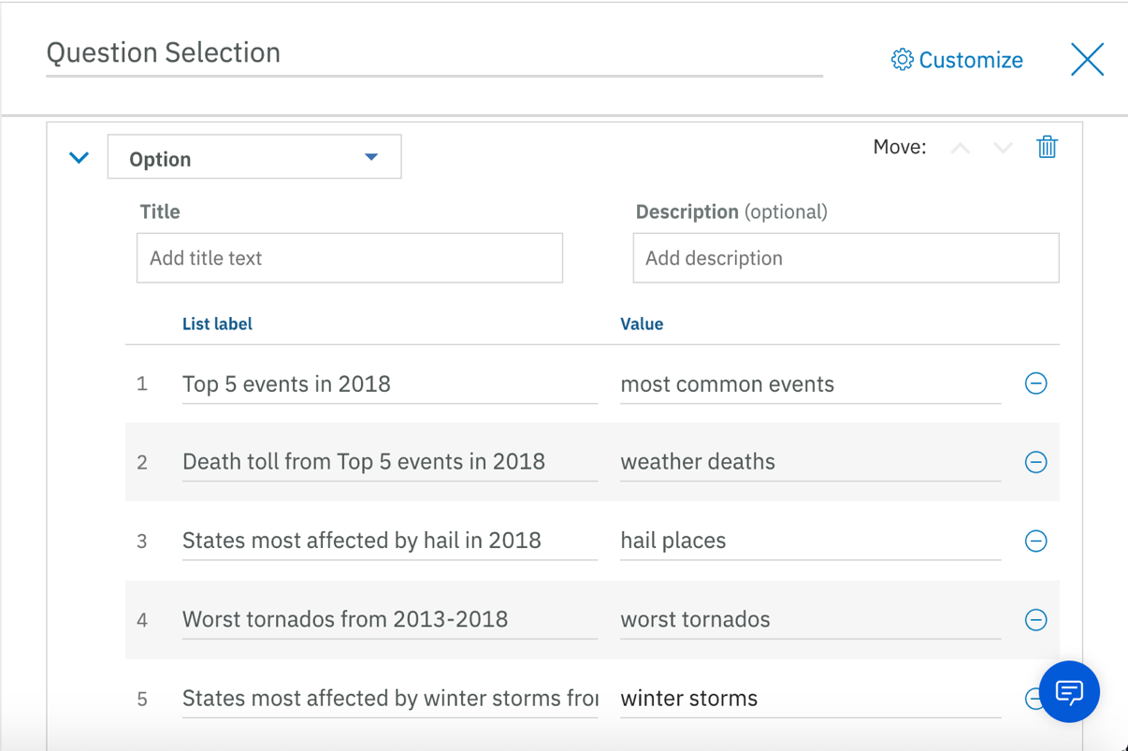

* Click the X button next to the Customize option in order to save and close this node
* Since we want to jump directly to the Question Selection node as soon as we see the Welcome message, click on the Welcome node and scroll to the bottom until you see **And finally.** Click on the down arrow and select **Jump to.** Select the Question Selection node as the destination node. When presented with the pop-up entitled “Jump to and,” select **Respond**.
* Click the X button to return to the Dialog screen.

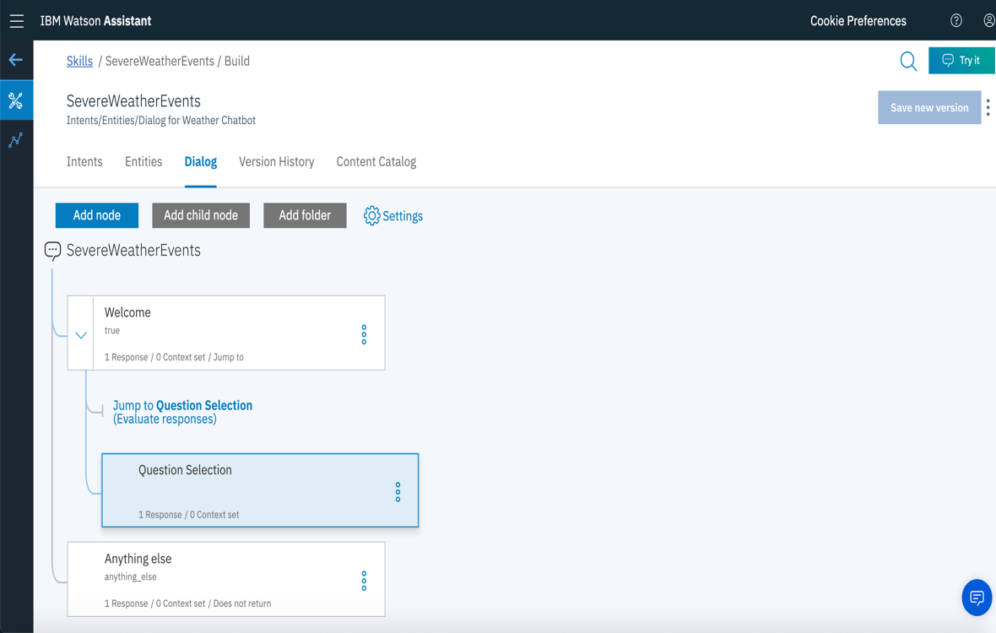

1. Preview the Watson Assistant chat flow so far by clicking on the **Try it** button on the top right corner of the Dialog page. Underneath the Try it out preview pane, you should be able to see the Welcome message immediately followed by the multiple-choice selection of 5 questions. We will now setup a question node for each of these five choices.

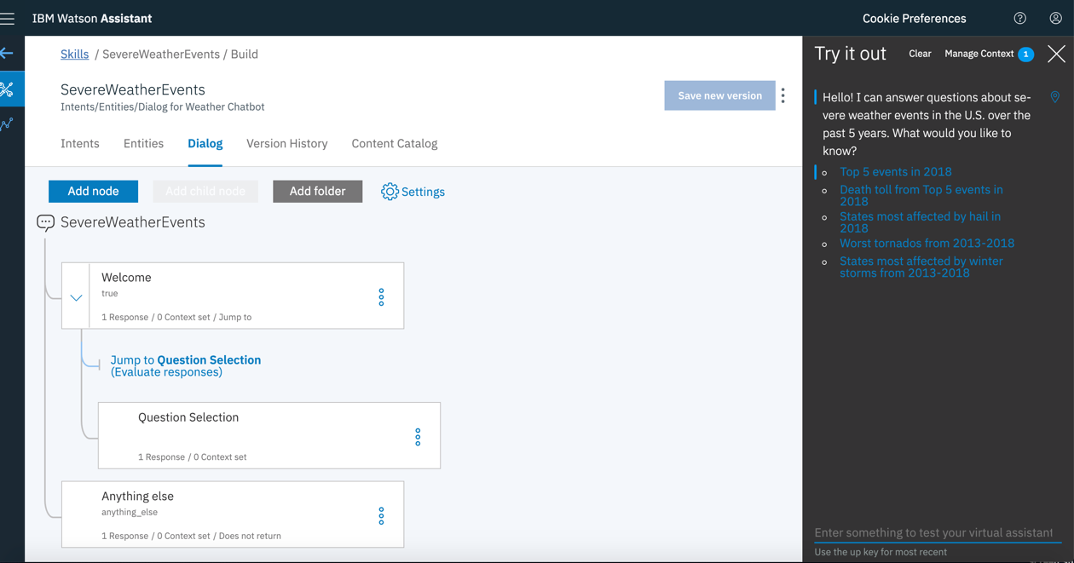

1. Let’s add the node for the first question. On the Dialog screen, without highlighting any of the created nodes, click **Add node**. Give the node the name **Top 5 Events**, under **If assistant recognizes:** type the intent **#mostcommonevents.** Under Then respond with, make sure Text is selected in the drop-down view and inside the response box, copy and paste the first line of your QueryResults.txt file: Thunderstorm Wind – 26 occurrences, Drought – 16 occurrences, Hail – 16 occurrences, Flash Flood – 9 occurrences, Marine Thunderstorm Wind – 7 occurrences

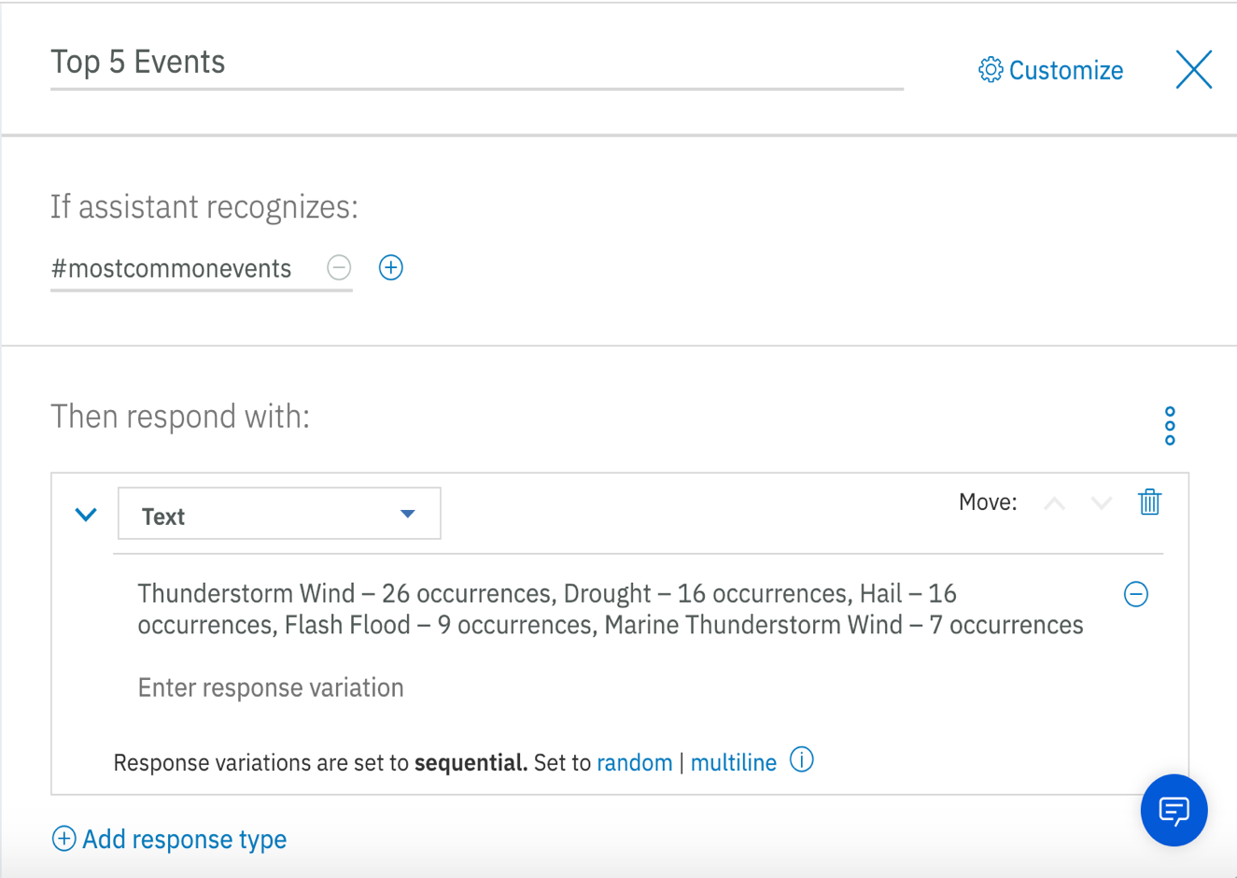

Click X to save and close the completed dialog node.

1. To create a node for the second question, click **Add node** on the Dialog screen. Give the node the name **Death Toll from Top Events**, under **If assistant recognizes:** type the intent **#weatherdeaths.** Under **Then respond with**, make sure Text is selected in the drop-down view and inside the response box, copy and paste the second line of your QueryResults.txt file: Thunderstorm Wind – 0 deaths, Drought – 0 deaths, Hail – 0 deaths, Flash Flood – 0 deaths, Marine Thunderstorm Wind – 0 deaths

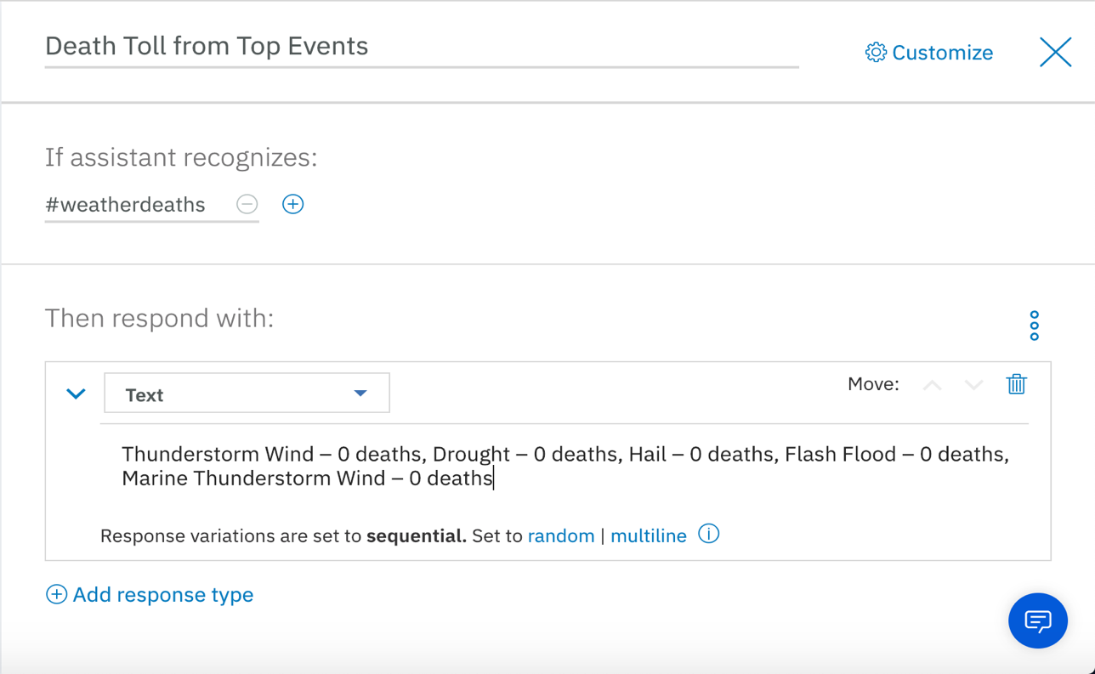

Click X to save and close the completed dialog node.

1. To create a node for the third question, click **Add node** on the Dialog screen. Give the node the name **Most Affected by Hail in 2018**, under **If assistant recognizes:** type the intent **#hailplaces.** Under **Then respond with**, make sure **Text** is selected in the drop-down view and inside the response box, copy and paste the third line of your QueryResults.txt file: Ohio – 4 episodes of hail, Idaho – 3 episodes of hail, Kentucky – 3 episodes of hail, Nebraska – 2 episodes of hail, Oregon – 2 episodes of hail

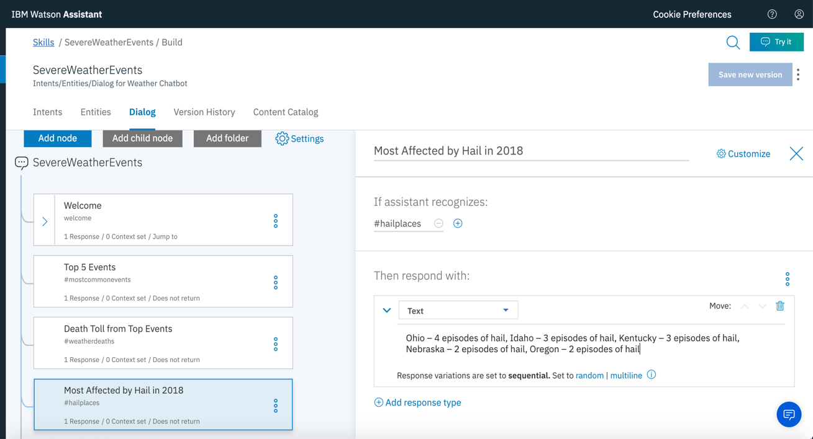

Click X to save and close the completed dialog node.

1. To create a node for the fourth question, click **Add node** on the Dialog screen. Give the node the name **Worst tornados 2013-2018**, under **If assistant recognizes:** type the intent **#worsttornados.** Under **Then respond with**, make sure **Text** is selected in the drop-down view and inside the response box, copy and paste the fourth line of your QueryResults.txt file: Florida – 2 EF0 tornados, Maryland – 2 EF0 tornados, Mississippi – 1 EF1 tornado

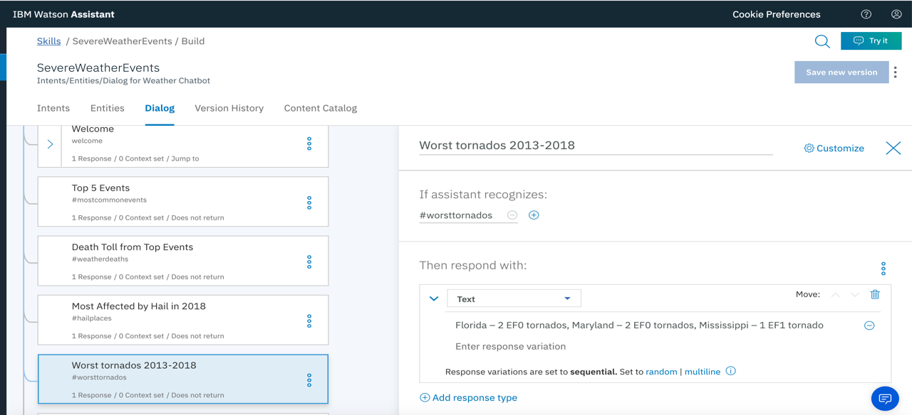

Click X to save and close the completed dialog node.

1. To create a node for the fifth question, click **Add node** on the Dialog screen. Give the node the name **Most Affected by Winter Storms**, under **If assistant recognizes:** type the intent **#winterstorms.** Under **Then respond with**, make sure **Text** is selected in the drop-down view and inside the response box, copy and paste the fifth line of your QueryResults.txt file: Virginia – 5 winter storms, New York – 4 winter storms, Wyoming – 4 winter storms, Colorado – 2 winter storms, New Hampshire – 1 winter storm

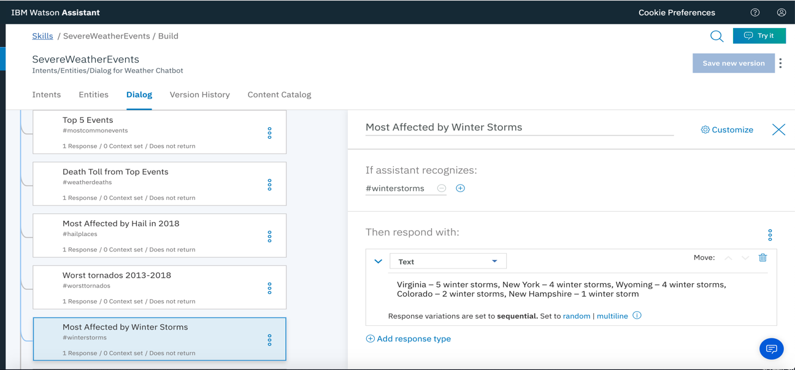

Click X to save and close the completed dialog node.

1. Click the **Anything else** dialog node. This node is triggered if Watson is asked a question it doesn’t understand or one for which it doesn’t have an answer. In that case, we will want Watson Assistant to communicate that it doesn’t understand to the user and automatically jump to the Question Selection node, so that the user can ask the appropriate question.

* Keep the name, the condition and the response text unchanged.
* Scroll down to **And finally** and click the down arrow to select **Jump to**
* Select the **Question Selection** node as the destination node. If it is currently not visible, select the side arrow on the Welcome node and now select **Question Selection**.
* In the Jump to and pop-up, select **Respond**

**Step 5: Test and Train Watson**

Now that we have created the Intents, Entities and Dialog for our Watson Assistant instance, let’s test it out!

1. Click the **Try It** button on the top right-hand corner of the page.
2. Click the first option “**Top 5 events in 2018**” to see the response generated by Watson
3. You should see that Watson has selected the intent #mostcommonevents in order to answer this question. If you see anything else in the drop-down view such as “Irrelevant,” make sure you click the down arrow and select #mostcommonevents in order to briefly train Watson. After retraining Watson, click Clear at the top of the screen to test the dialog again.

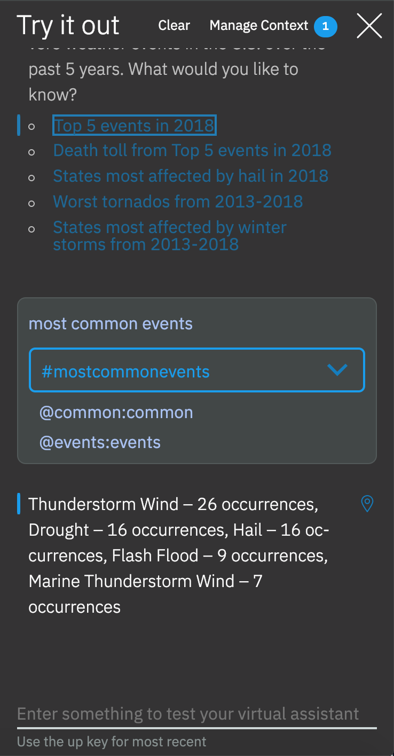

1. Now type in “**What was the death toll from the most common severe weather events?**” You should see that Watson returns the death count for the top 5 most common weather events from 2018:

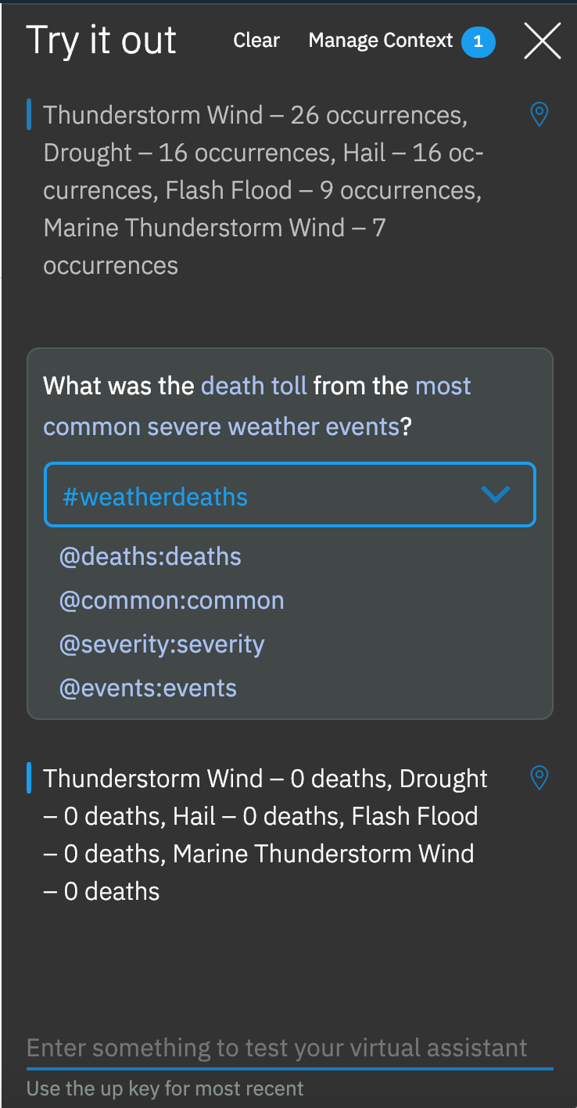

1. Go ahead and test the remaining 3 questions similarly and make sure Watson returns the correct response each time. Once again, if you find Watson using an incorrect intent such as “Irrelevant,” please manually select the correct intent and allow Watson to retrain. Make sure you click Clear after retraining Watson.
2. Finally, let’s see what Watson tells us if we ask it something else. Type in “**Where was the deadliest hurricane in 2018**?” The intent used by Watson should be “Irrelevant” in this case and after saying that it didn’t understand your question, Watson should immediately return the multiple choice selection of questions.

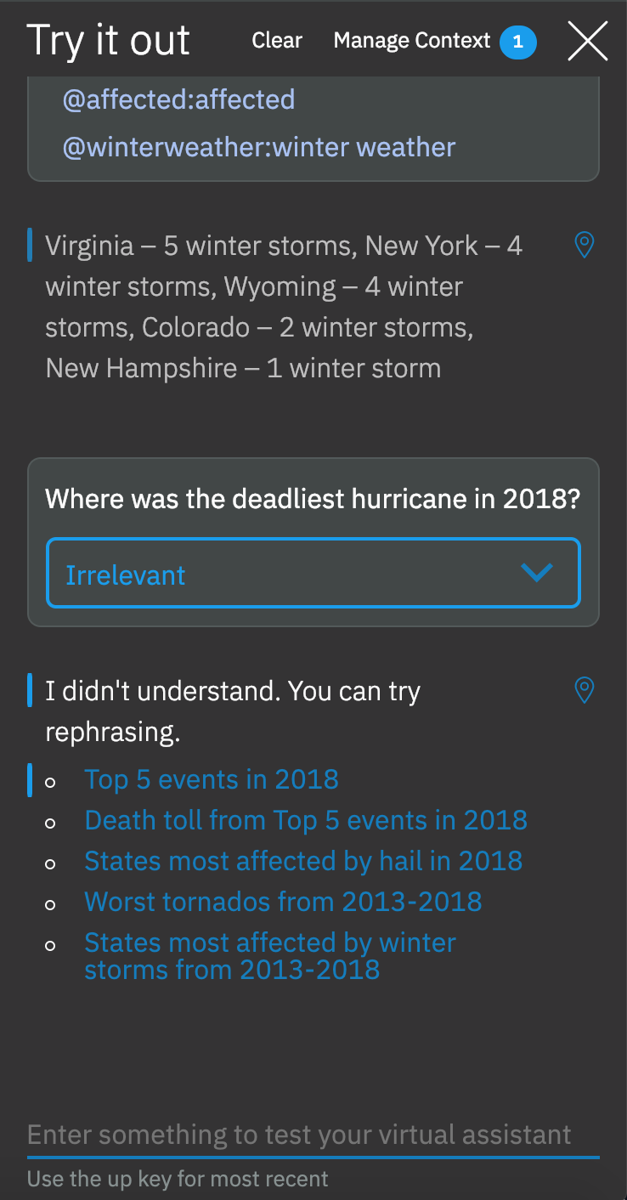

**Step 6: Save your Watson Assistant Workspace**

Congratulations! You have just created your very own Watson Assistant that has been trained to answer questions about severe weather events. The last part of the lab is to save this created instance.

1. Click the blue left arrow on the left side of the Skills page.

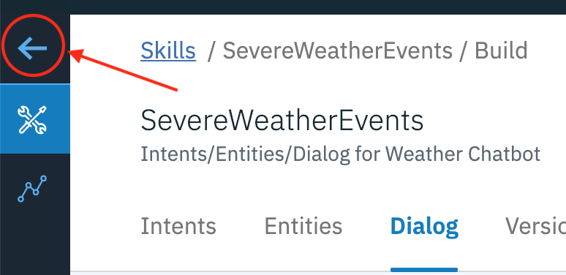

1. Now click on the Watson Assistant home page, select your SevereWeatherEvents skills instance and click the 3 vertical dots to select **Download JSON**. This will automatically download the workspace JSON file for your Assistant instance that you can use within your application.

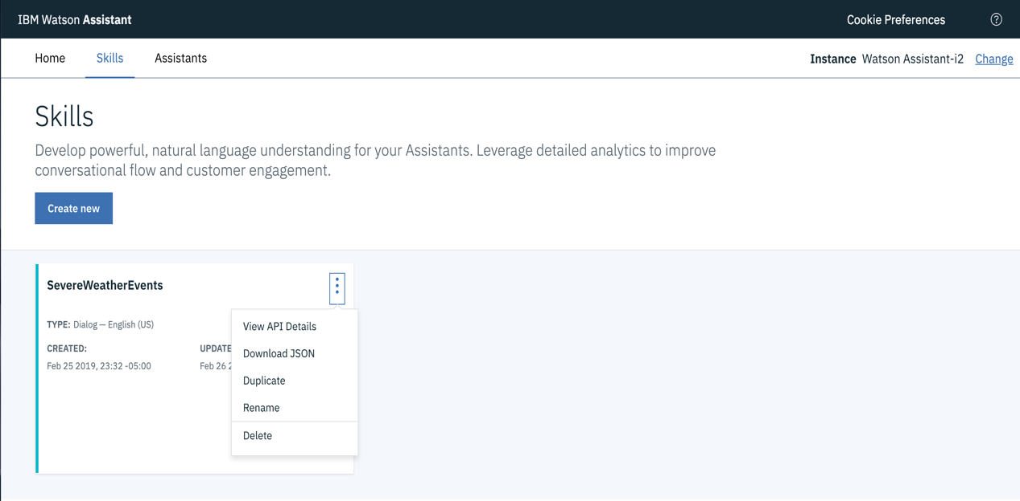

1. Click on the 3 vertical dots again to select **View API Details**. This will take you to a page showing the credentials for your Watson Assistant instance such as the Workspace ID, Workspace URL, username and password. These credentials will also be needed for the completion of the application in the next lab. Copy and save all details and credentials on this page.